**Name:** Atlee Hlavinka

**Github Portfolio Link:** atleehlavinka.github.io/AtleeHlavinkaPortfolio/index.html

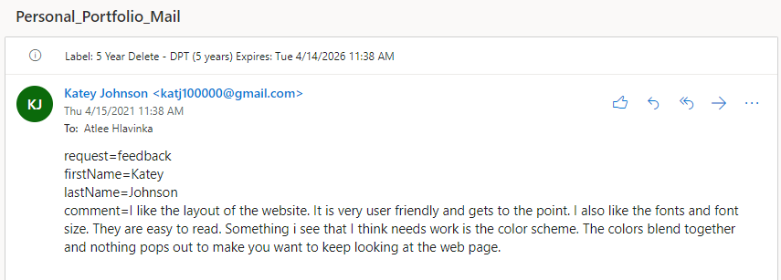

(61 words)

**My Response to the Peer Review:**

I agree that I need to work on improving the color scheme. I was trying to keep it simple, but more could be added to help make the website more interesting.

**Browser Compatibility Testing:**

1. **Chrome:** Consistent Appearance
2. **Firefox:** Consistent Appearance
3. **Edge:** Consistent Appearance
4. **Opera:** Consistent Appearance